Ref <http://www.instructables.com/id/Low-Cost-Spirometer/>

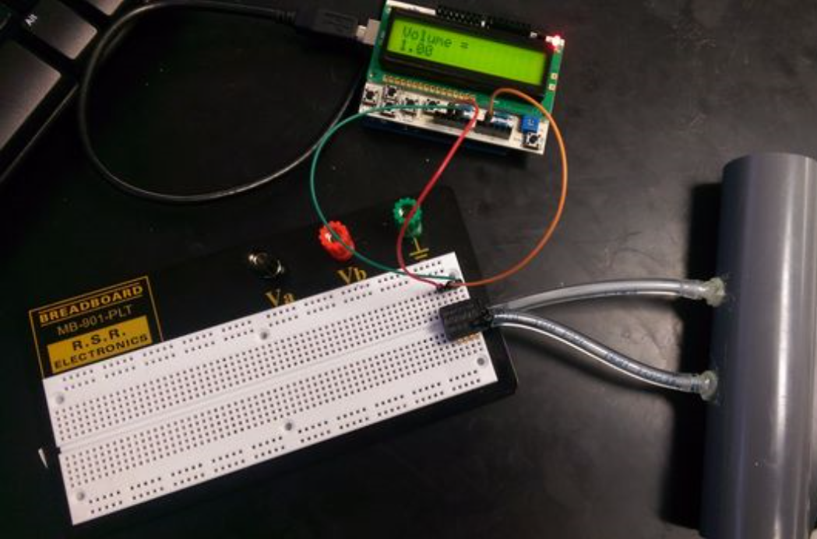

As I am not an electrical engineer I had to find a tutorial to help me figure out the steps that would be need to create a spirometer. I followed the following instructables tutorial.

Materials :

* Pvc pipe (might look for a better solution)
* Plastic tubing
* Glue
* Pressure sensor
* Arduino Uno
* Arduino Uno LCD screen
* Computer
* Micro usb cable
* Bread Board (might not need this)

Step 1 construct spirometer tube :

The tube should have two sections, one with a large diameter and one significantly smaller diameter eg D1 = 2.3, D2 = 0.6 (make larger diameter difference)

Step 2 select pressure sensor :

The only circuit component used for this project is a pressure sensor, Honeywell ASDX series silicon pressure sensor.

Differential pressure sensors are able to convert the difference between two pressure to voltage. A diaphragm is placed between two compartments of the sensor each compartment has a port where pressure can be applied. The diaphragm is attached to a series piezoresistive strain gauges the that are connected in a wheatstone bridge configuration. As the resistance changes the output of the bridge circuit changes and can be used to calculate the pressure difference. The sensor requires connections to a supply voltage (5V) and ground.

Step 3 Attach Arduino uno microcontroller :

Another major component of this device is the Arduino uno microcontroller and a compatible LCD screen with buttons.

Connecting the arduino to the pressure sensor is very simple you just need to match the sensors pins to the pins on the board. Since the arduino is able to supply 5V and ground you will be able to power the pressure sensor with the arduino alone.

Before attaching the wires for the pressure sensor to the arduino attach the LCD screen to the microcontroller. It should fit into the pins on the arduino.

Configuration

* Pressure sensor -> Arduino
* Pin 1 -> 5V
* Pin 2 -> A1
* Pin 3 -> GND

Step 4 creating the code :

The following are the steps the tutorial used to explain the logic behind the code :

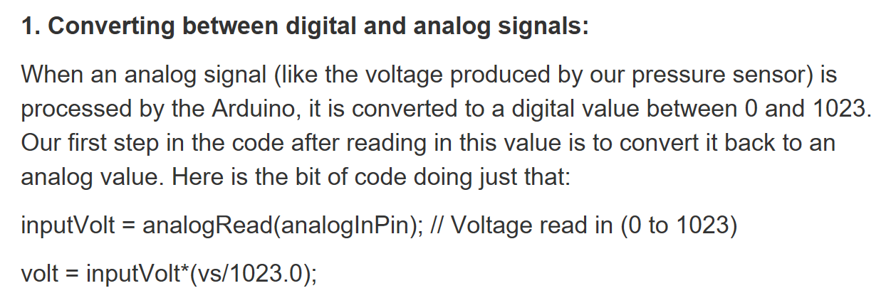

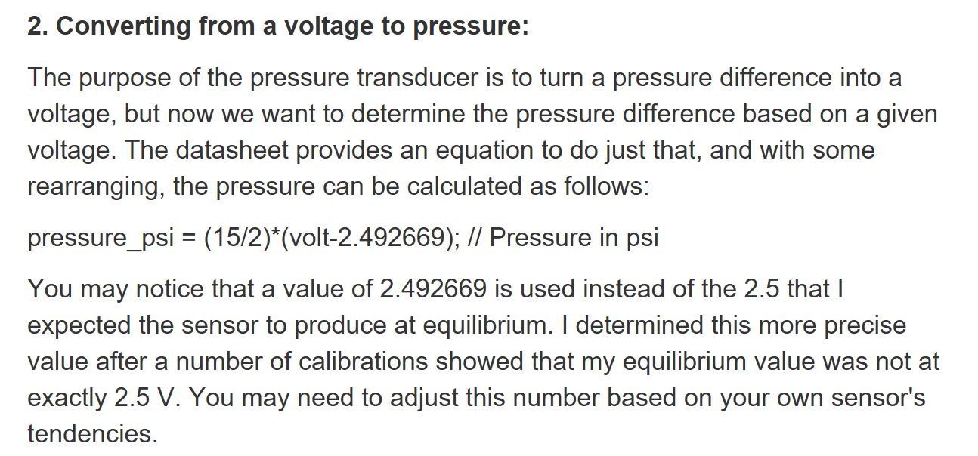

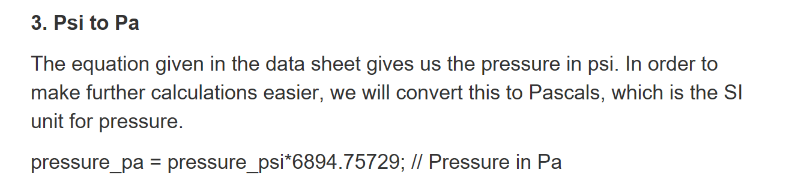

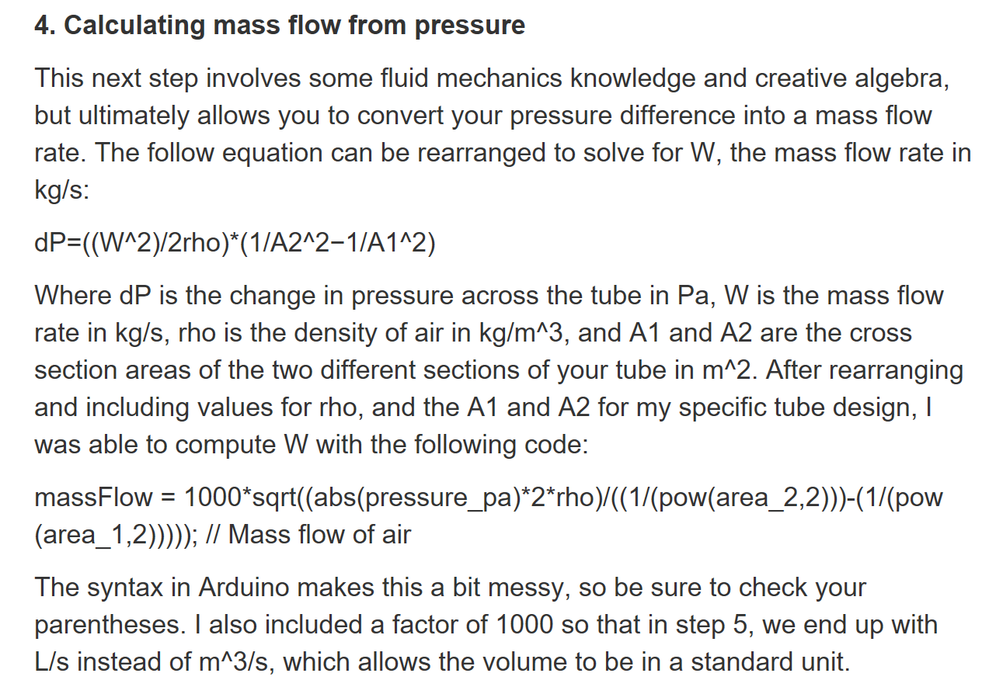

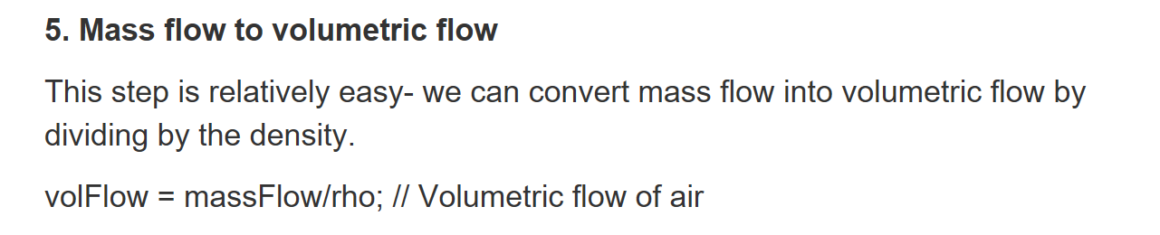

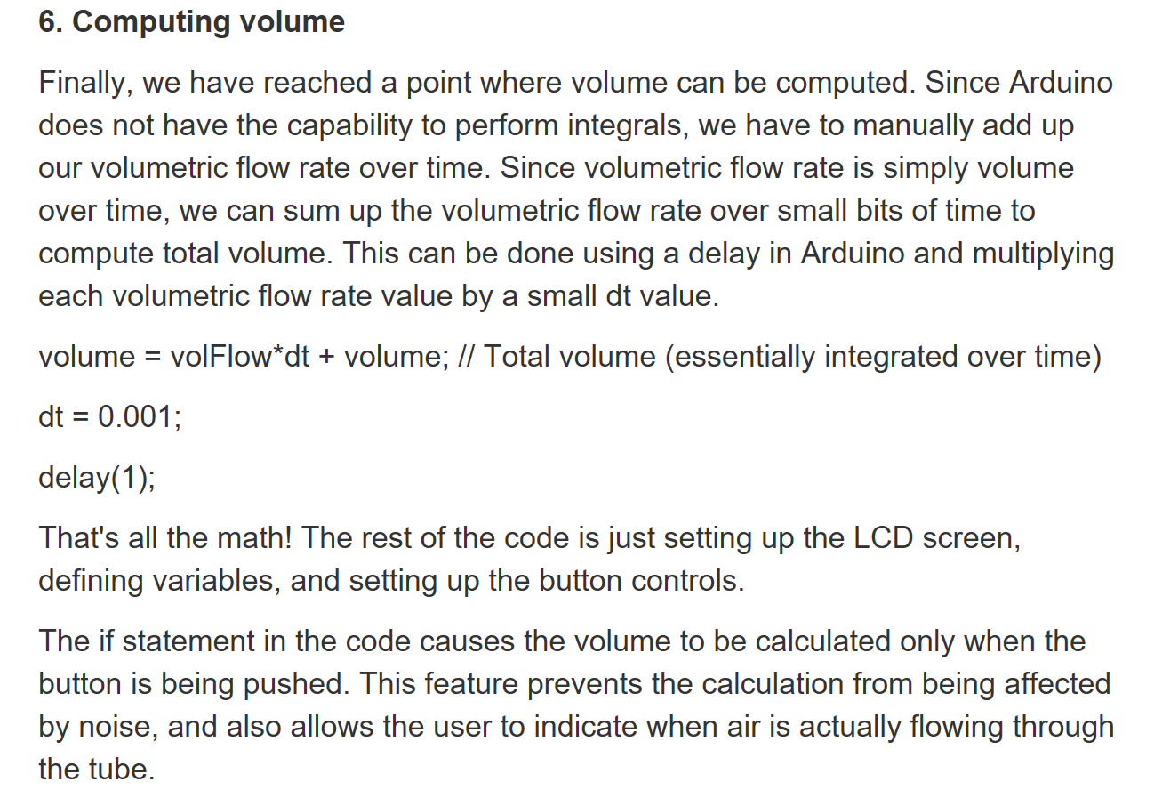

Step 5

In order to use the device attach the tube from step 1 to the pressure sensor using the two pieces of tubing.

Bring the tube to your mouth and blow through it, while simultaneously pressing the up button on the LCD screen. When finished expiring release the button.